Seen Music: Ambient Music Data Visualization

for Children with Hearing Impairments

**ABSTRACT**

In this paper, we propose a prototype of music visualization system that captures and records the music component into digital data form, and then displays the data in visual form for children with hearing impairments. The analog sound data of music played physically is scaled into a binary matrix and scalar values that is then used as data structures for transcribing the output. We designed a system detecting tune and speed from a physical violin, and demonstrated three tangible music visualizations that children see in their daily lives, employing a flowerpot, plants and a picture of frame. We describe how the data captured from physical musical instruments can be seen through these objects, and suggest future possibilities for interactive sound visualization in music education for children with hearing impairments.

**Categories and Subject Descriptors**

D.2.2. [**Software Engineering**]: Design Tools and Techniques-Evolutionary Prototyping, Modules and Interfaces, User Interfaces; H.5.2. [**Information Interfaces and Representation**]: User interfaces-Interaction styles, User-centered design, J.5. [**Computer Applications]:** Arts and Humanities-Performing Arts.

**General Terms**

Human Factors, Design

**Keywords**

Music Visualization, Music Education, Assistive Technology

# INTRODUCTION

Permission to make digital or hard copies of all or part of this work for personal or classroom use is granted without fee provided that copies are not made or distributed for profit or commercial advantage and that copies bear this notice and the full citation on the first page. To copy otherwise, or republish, to post on servers or to redistribute to lists, requires prior specific permission and/or a fee.

*Conference’10*, Month 1–2, 2010, City, State, Country.

Copyright 2010 ACM 1-58113-000-0/00/0010 …$15.00.

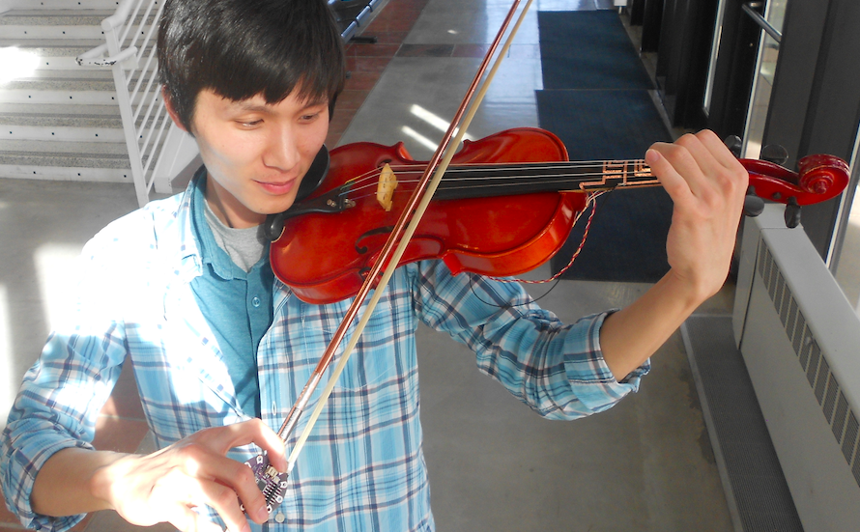Since music has been shown to play a significant role in relieving stress, understanding beauty, and developing empathy skills, it has been taught in classroom settings from early childhood [7]. Understanding components of music such as, melody, harmony, and rhythm, is the main theme of music education in classrooms. Although many researchers and interaction designers have thought of a computer added tool for early childhood music education (in part because of the unique property of music itself), teaching music for education is not easy for teachers of children with hearing impairments. Only limited parts of music was felt by kids having hearing defects, such as feeling beats throughout vibrations. We suggest a system that integrates the process of recording physical music, interpreting music data, and translating it into visible form. Our design goal includes four main considerations:

Figure 1. Playing violin with Seen Music system to capture tune, and rhythm, components of music.

* **Capturing physical music sound in digital format:** There are several ways available of recording analog music data, and interpreting it into digital form using signal processing. To simplify the process, we designed a system to directly capture digitized sound, and save it in an efficient data structure for digitized visualization.
* **Cost effective rapid prototyping:** Integrating many delicate sensors enables the preciseness of captured music data. However, keeping the system as simple and cheap as possible allows the general public to use the proposed design widely in classrooms for the hearing impaired.
* **Visualization of music with tangibles:** Feeling music with all the senses is highly recommended for music education, especially for children. Although the main goal of the system is visualizing sound for children with hearing impairments, we designed the visualizations to be tangible and tactile, thus enriching the music experience for non-impaired children as well.
* **Time effective differentiation of visualization:** With the least amount of time required, our system provides fluent differentiation of visualization patterns, encouraging users to free transform and customize the visualization.

# BACKGROUND

## Music Education for Children Who Need Special Help

Music was traditionally used in education for building emotional sympathy skills in early childhood. However, for children with hearing impairments, it is challenging to teach the concepts of melody and rhythm in music since it is primarily based on sound.

We conducted casual semi-structured interviews with teachers of deaf students, to understand how music has been traditionally taught for children with hearing impairments. There are a few ways to enable children feel the music. The easiest way is signing lyrics of songs in *ASL*[1], and teachers also used large drums or speakers so children can feel the vibrations through their hands on them. They also used videos to “show” the degree of music, and recently, and integrated a sound reactive music light to express components of music in visualized forms. One of the schools for deaf students is building a vibrating floor with speakers underneath to help children feel the music through floor vibrations.

A similar solution invented by Hyundai, called *Touchable Music Seat*, uses vibrating seats to help people with hearing impairments to feel the music while driving. Several samples of these seats have also been installed in classrooms [5]. For those who cannot listen to the sound, the seat provides precise vibrations based on music beats to those sitting in the car. However, our question left unanswered, how *melody* and *timbre* could be delivered with *rhythm* that interpreted by these method at the same time?

## Sound Visualization

Information Visualization, especially music has become a rising interest among practitioners, educators, artists, and researchers. The equalizer (Figure 2, left) is the most common and accessible form to show how tune and rhythm of music progresses over time, with various colors of lines and geometries representing pitch, and height and gaps between bars representing amplitude and frequencies, respectively. Installation artists have used a combined series of LEDs, motors, and sensors to visualize various components of music. A good example is the *Dancing Music Water Fountain* as shown in Figure 2 (right). With appropriate mapping from music notes to the combinations of colors and movements, melody of music can be efficiently delivered to children with hearing problems, while the frequency of color change and movements can represent rhythms.

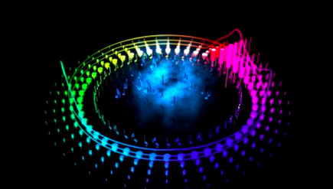 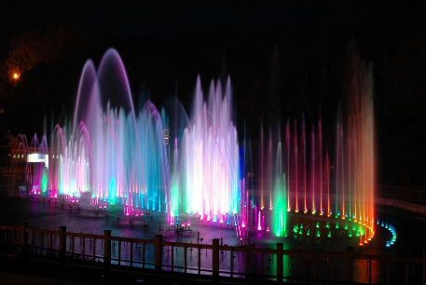

**Figure 2. Equalizers visualize music in vivid colors and geometry (left), and music fountain presents music with direction or height of water released, colors reflected (right).**

## Tangibles for Information Display

Last year, *Muzlog* presented how the sound of physical instruments can be taken in digital format directly, by seizing pitch and stroke into digital music notes [6]. Likewise, *Coolmag* also tried to think how tune could be generated by interface of random musical instruments [12]. Those two works are good starting points for catching analog melodies to readable digital form. Early *Noteput* project explored graspable representations of notes, to compose and play music with tangibles on the screen interactively [3]. Putting physical notes on an empty digital manuscript, which is projected on a tabletop interface, enabled recognizing tune by the controller automatically.

Meanwhile, *Laughter Blossom* presented the artificial flower that interacts with people as an ambient form of information display [11]. It proposed a tangible way of symbolizing the sound of laughter in visual form, through a blossoming flower. In this way, they opened a possibility for natural phenomenon to represent music. *Laughter blossom* was originally inspired by *LaughingLily*, which used digital flowers as a mean of information visualization [1]. The number of flowers, the shape of the petals, colors, and the level of blooming all affected how the flower expressed data. Another example of information display with ambient objects was *Infortropism* [4], that manipulate plant’s leafs to correspond to the density of light being projected, through degree of bend and lean.

As the *Muzlog* system and *Noteput* project were limited to input of music and were not designed for children with hearing impairments, in our design we employ, (1) information visualization through objects children might encounter in their daily lives and (2) interactive tangibles for capturing and expressing music that will hopefully empower children to learn and feel music in classroom.

# IMPLEMENTATION

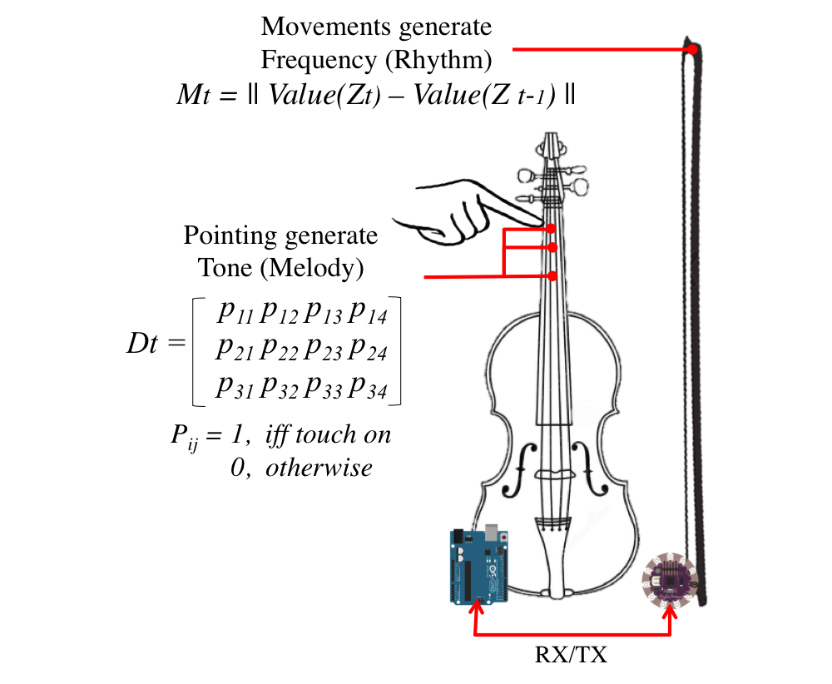

**Figure 3. Music data (Rhythms and Melody) generation and data schema to transfer into music visualization system**

Our system consists of two modules, one for capturing physical music data and the other for interpreting this data into an ambient display. In our system we combine violin performance with three applications of information display. The software application was programmed in Sketch [2] and can translate violin sound to three different output modes, (1) analog ranged (0 ~ 180°) output into one servo for flower, (2) binary ranged (High/Low) output into one vibration motor for plant pot, and (3) six binary ranged output into LEDs for picture of frame. A LilyPad Arduino coupled with an accelerometer on the bow of the violin transmits data to a main Arduino Uno board via a serial communication bus (Figure 3). The main Arduino also receives data from the fingerboard of the violin, and transmit output signals into display.

## Collecting Physically Played Music Data

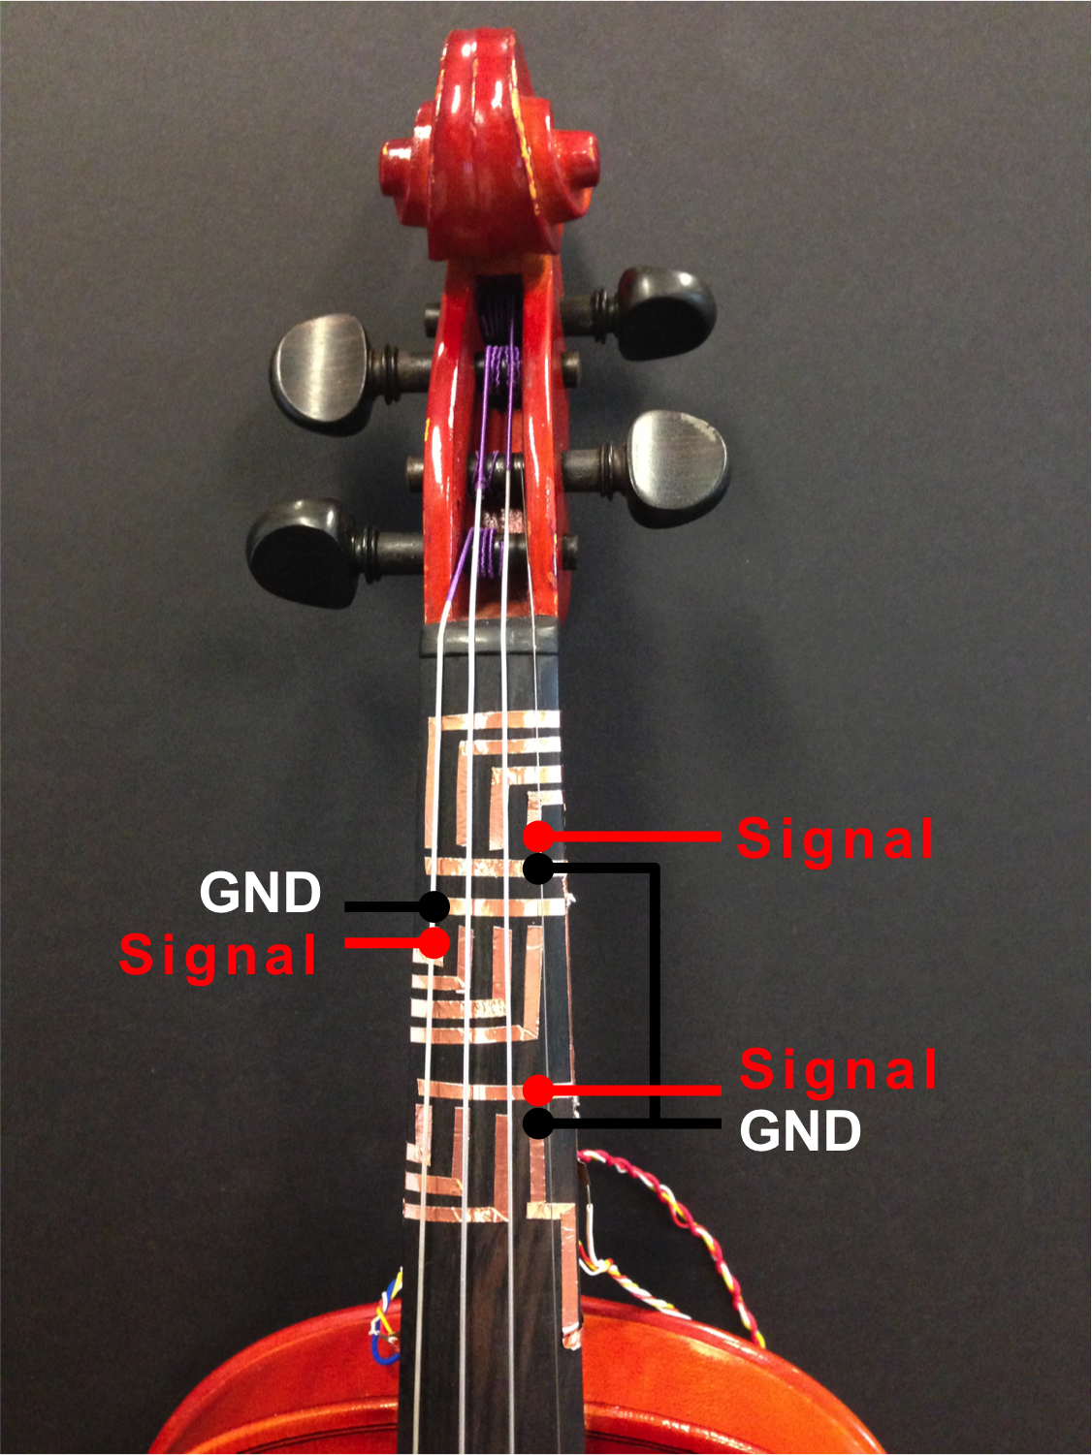 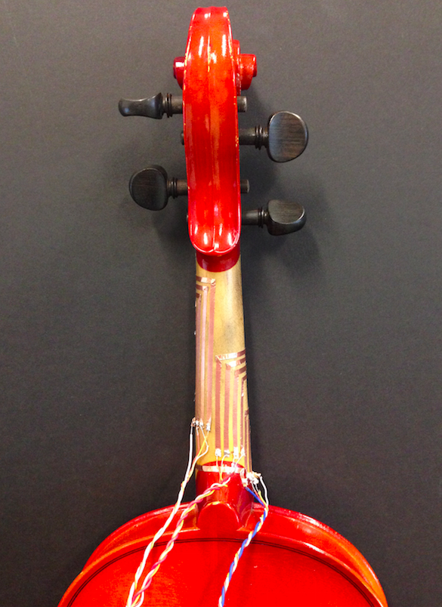 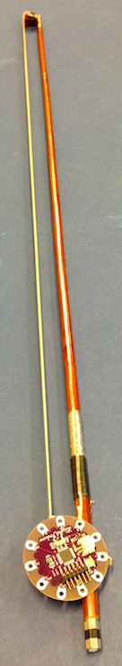

**Figure 4. Initial settings for detecting tune of violin play. Each of three positions on the fingerboard has four digital input by four strings, closed the circuits grounded by finger touch.**

Transcribing physically played music into digital form is neither easy nor simple, needing a special system to interpret the data. For example, to avoid noise, a musician should play instruments in a soundproof room. It also requires signal processing to interpret components of music since recorded music is still in analog form. Not only that, the analog frequency and amplitude should be quantized to integer, in order to be digitized. To ease this process without a complex computer system, we designed a circuit for capturing touch signals, which is attachable to almost any kind of musical instruments. With the violin for example, we designed the proper data structure to record data as shown in Figure 3. As a violinist touches the fingerboard to generate chords while playing, s/he closes copper tape based circuits. Finger touches on the violin neck trigger subtle resistance changes that can be used to code finger position. The main Arduino board is attached to the back of body. Since the fingerboard only generates the level of tune, we also employed an accelerometer (connected to a Lilypad) at the tip of the bow to capture the dramatic z-axis movement while playing. Two controllers connect each other by wires for serial communication, since the bow would be otherwise too heavy for wireless communication modules such as Xbee.

## Musical Data Visualization

Our goal in projecting music data into ambient visualizations [10] is to help children appreciate the aesthetic quality of music. Much as people listen to music anywhere, anytime, with anything (CD player, smartphone, Radio, etc.), we hope hearing impaired children can enjoy music through everyday objects. Now we propose three different types of ambient visualizations.

*3.2.1. Blooming Flower*

Based on the kind of objects, different forms of mapping can be realized. *Laughter flower* and *Laughing Lily* inspired us to design a flower blossoming through a servo, synchronized with the violin playing. The degree of blooming flower’s petal is mapped to the servo’s rotational degree from 0 to 180°, which is transcribed from tune data from the string input. We planted three flowers with one servo with every 60° assigned to one position on the fingerboard position, and 15° to four strings at one position, so that it could present 3 by 4 matrix. Each of the flowers was attached to the rotating axis of the servo pivot, enabling movements in both directions. The speed was normalized to scale, and sent to direct speed. The degree of the motor rotation was calculated by passing the position of the data in the Dt matrix over time as a parameter to the data mapping function.

for (rows = 1:3, cols = 1:4) in Dt

Servo.write( rows*60 + cols*15);

LED(rows, HIGH);

delay(Mt);

If we embed three motors, assigning each to one flower, we can individually map each to three positions, allowing larger blooms. LEDs embedded into the flower stamen can also show some degree of data, by gradually dimming to represent sound duration.

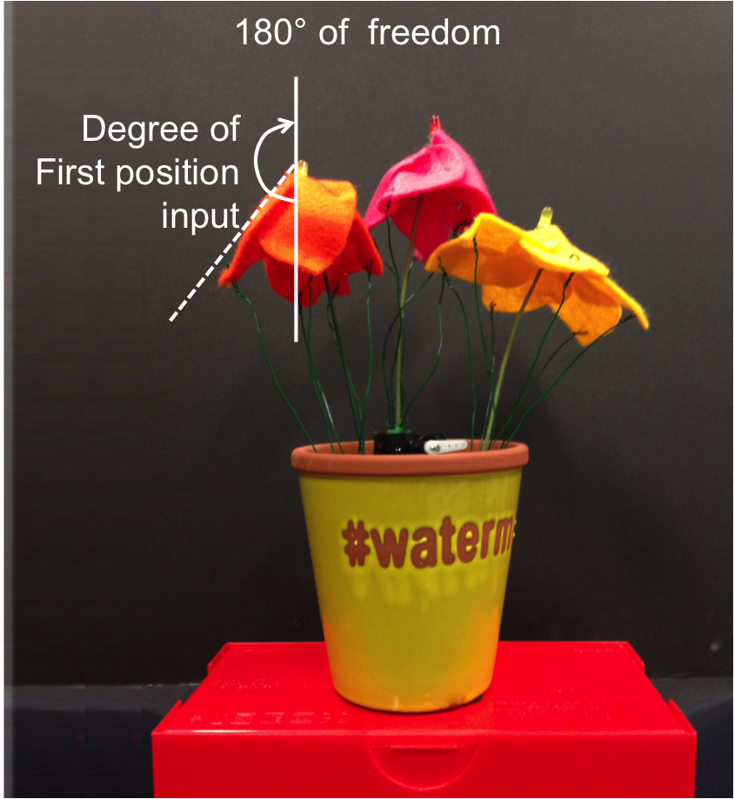 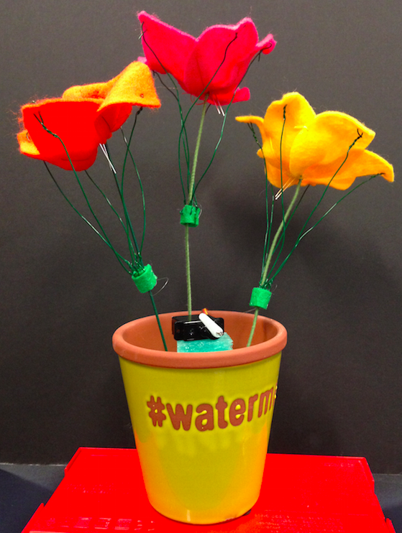

**Figure 5. Blossom’s petals move up and downs by servo in horizontal direction, stating from blooming or closing.**

*3.2.2. Waving plants*

In the second waving plants example, the direction of lean in plant can also be used to demonstrate data. We attached pairs of leaves to the several horizontal axes to plug movements along with spinning motor. Owing to the axes are attached to leaves by Velcro tapes, users can choose the number of leaves to attaché, differentiating movement positions. Since the servo can rotate up to 180°, the leaves can lean in the left and right directions, and with enough high speed, mimic vibration.

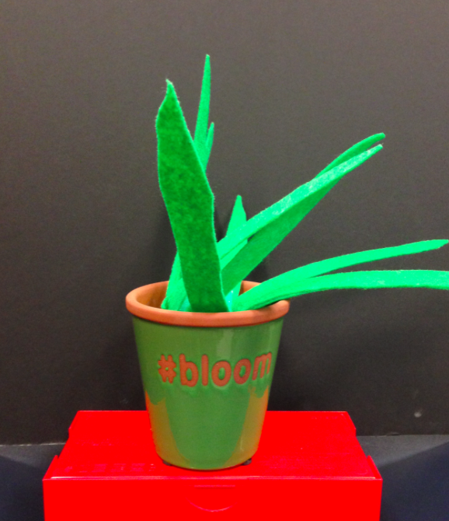 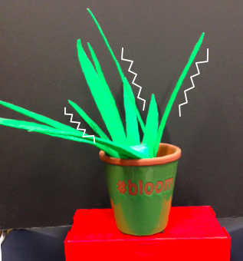

**Figure 6. Waving plants that indicated melodies and rhythm. If user turns the state of plant off to binary, it simply vibrates over time while music plays.**

*3.2.3. Colored Frame*

The window reflecting sunlight is one of the most common objects found around children. Inspired by colorized stained glass, we similarly designed two types of transparent frames, one that was laser engraved (Figure 7, left), and another that was a cut pattern (Figure 8, right). We assigned six different colored digital LEDs to represent 12 strings As the music proceeds slowly, the LEDs incrementally turn on and allow for a variation of colors to represent music.

|  |  |  |  |  |  |  |
| --- | --- | --- | --- | --- | --- | --- |
| LED | White | Violet | Green | Blue | Yellow | Red |
| Trigger | *p11, p31* | *p12, p32* | *p13, p33* | *p21, p11* | *p22, p12* | *p23, p13* |

**Table 1. LEDs assigned to 12 inputs**

The output board simply projects colors through a serialized array of LEDs and dimming is used to represent how long the sound sustains. We used a transparent acrylic sheet, so that the LEDs light up through to the front. The engraved pattern refracts light creating a more salient image. At the same time, it is also tangible since the patterns are concave.

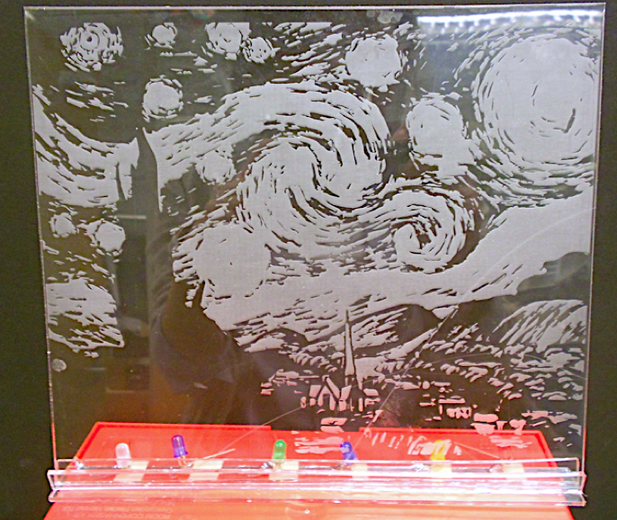 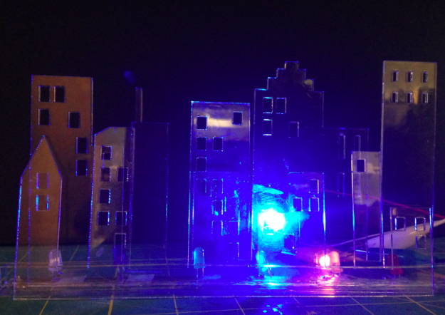

**Figure 7. Laser engraved pattern of “*Starry Starry Night*” with six LEDs installed into standing slot (left), and an overlayed laser cut frames of city skyline with blue and orange color LEDs enabled (right)**

# DISCUSSION

Our prototype could also be applied to other musical instruments that trigger sound through push or touch, such as the flute or the piano. Visualizations can be used for early stage childhood music education. While the physical visualizations are not as precise as screen output, these objects make *natural* movements that maybe embody natural athletics of music. This could be beneficial to children for developing emotional empathy, but at the same time, this also could be a limitation of data visualization.

This rapid prototype of music capturing and visualization is simple, not wholly representative of actual music. However, this is a trade-off between cost and delicacy. The chords of open strings are not captured, because our system needs at least one grounded position on the fingerboard as an input signal. This could be replaced by the 4th position of the previous string, but it does not guarantee freedom to the performer. This could be remedied by applying *CordUIs* [9] to strings, recognizing the stretch level of strings through a stretch sensor. Including more sensors, will only enrich the detail of data visualization, however, it costs more and increases complexity. It could possibly increase the stress level of the user because of increased information overflow.

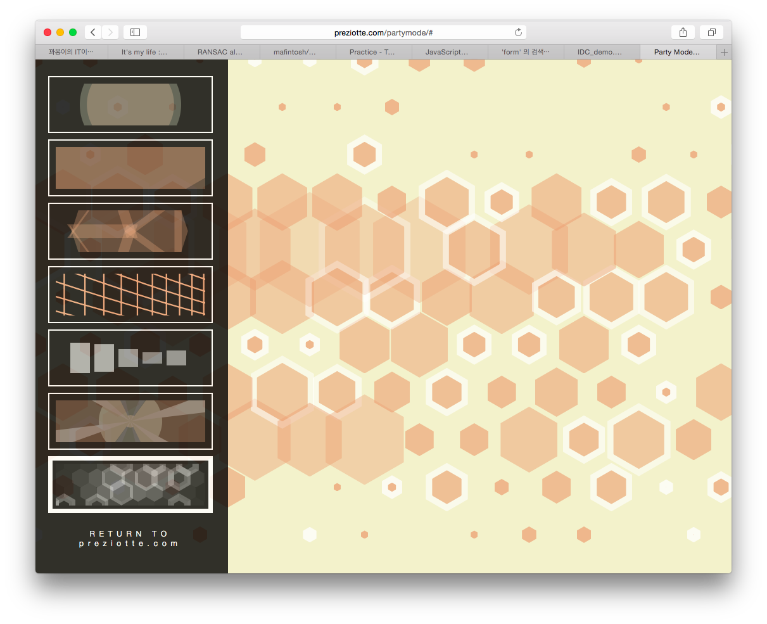 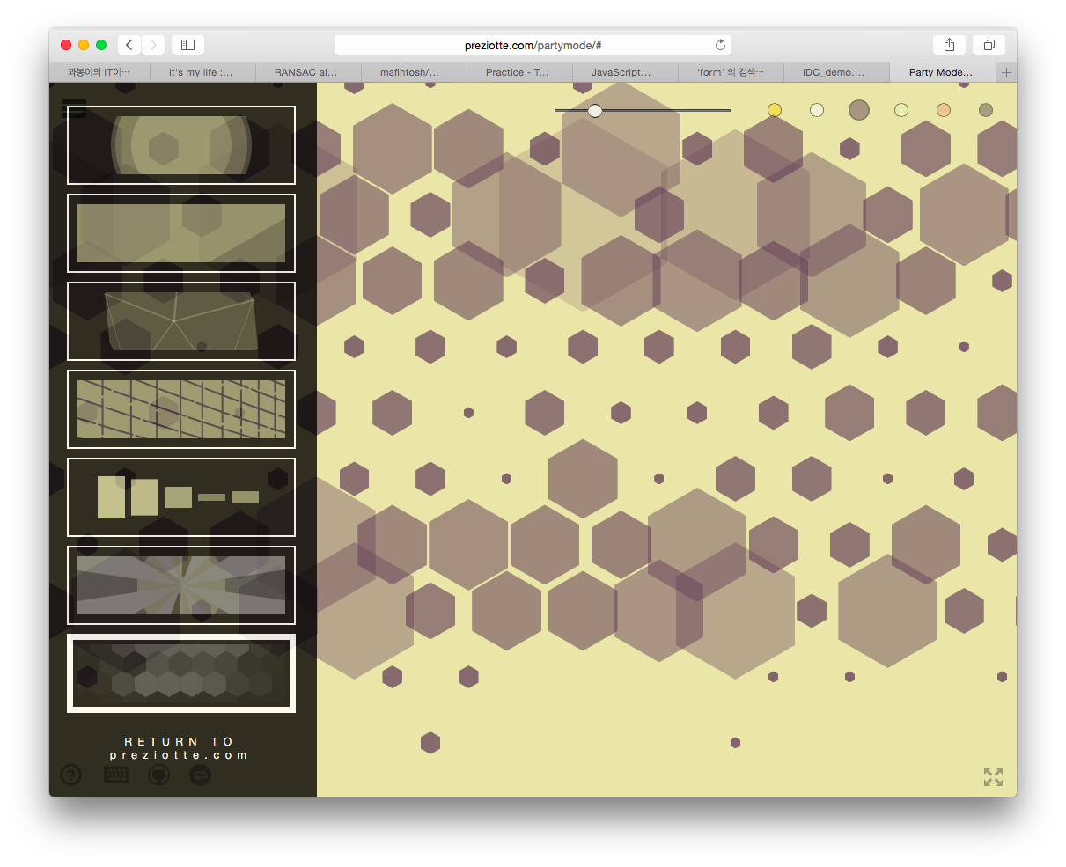

Figure 8. Hexagon geometries pattern mode in *PartyMode* CSS visualization library

In the future, we need to conduct a user study to examine if the different visualizations actually help music comprehension in hearing impaired children, and what needs to be added to guarantee music perception. We plan to expand the instruments range that our prototype can be applied, not only to violin, but also to piano, etc. We are also considering building a CSS visualization library, can be used with any screen in the classroom. Figure 8 shows a *Partymode* library that reads music data and represents it to the user in different colors, size, and geometry patterns [8]. To empower children’s deep engagements in music, we could also design a virtual game character that reacts to the music played by the instruments, by facial expression, or motion, etc.

# REFERENCES

1. Antifakos, S., and Schiele, B. LaughingLily: Using a Flower as a Real World Information Display.In *Proceedings of the 5th International Conference on Ubiquitous Computing, Ubicomp '03*
2. Arduion. <http://arduino.cc>
3. Heuer, J. F, *Noteput* <http://www.jonasheuer.de/index.php/noteput/>
4. Holstius, D., Kembel, J., Hurst, A., Wan, P., and Forlizzi, J. 2004. Infotropism: living and robotic plants as interactive displays. In *Proceedings of the 5th conference on Designing interactive systems: processes, practices, methods, and techniques (DIS '04).* ACM, New York, NY, USA, 215-221. DOI=http://doi.acm.org/10.1145/1013115.1013145
5. Hyundai Car, *Sonata Touchable Music Seat* <https://vimeo.com/65620958>
6. Kim, H., and Nam, T-J. 2014. Muzlog: instant music transcribing system for acoustic guitarists. In *CHI '14 Extended Abstracts on Human Factors in Computing Systems (CHI EA '14).* ACM, New York, NY, USA, 451-454. DOI=http://doi.acm.org/10.1145/2559206.2574774
7. Mckinnon, I., 2005. Children's music journey: the development of an interactive software solution for early childhood music education. *Comput. Entertain. 3, 4* (October 2005), 1-10. DOI=http://doi.acm.org/10.1145/1095534.1095547
8. Preziotte M., *Party mode* <https://github.com/preziotte/party-mode>
9. Schwarz, J., Harrison, C., Hudson S., and Mankoff, J. Cord input: an intuitive, high-accuracy, multi-degree-of-freedom input method for mobile devices. In *Proceedings of the SIGCHI Conference on Human Factors in Computing Systems (CHI '10)*. ACM, New York, NY, USA, 1657-1660. DOI=http://doi.acm.org/10.1145/1753326.1753573
10. Wisneski, C., Ishii, H., Dahley, A., Gorbet, M., Brave, S., Ullmer, B., and Yarin, P. 1998. Ambient Displays: Turning Architectural Space into an Interface between People and Digital Information. In *Proceedings of the First International Workshop on Cooperative Buildings, Integrating Information, Organization, and Architecture (CoBuild '98),* Norbert A. Streitz, Shin'ichi Konomi, and Heinz Jürgen Burkhardt (Eds.). Springer-Verlag, London, UK, UK, 22-32.
11. Yoon, S., Lee, Y, Nam, T, Lee, K *Laughter Blossom: A Prototype of Laughter Interaction Design*, In Proc. *IASDR’13*
12. Zhang, C., Shen, L., Wang, D., Tian, F., Wang, H. 2011. CoolMag: a tangible interaction tool to customize instruments for children in music education. In *Proceedings of the 13th international conference on Ubiquitous computing (UbiComp '11)*. ACM, New York, NY, USA, 581-582. DOI=http://doi.acm.org/10.1145/2030112.2030223

1. American Sign Language